ARCATECH UART COMMUNICATION

**NOTE:**

Establish communication between meter and radio, receive data without losing one bit.

Can only possible when below settings are met.

**UART SETTINGS (for Radio):**

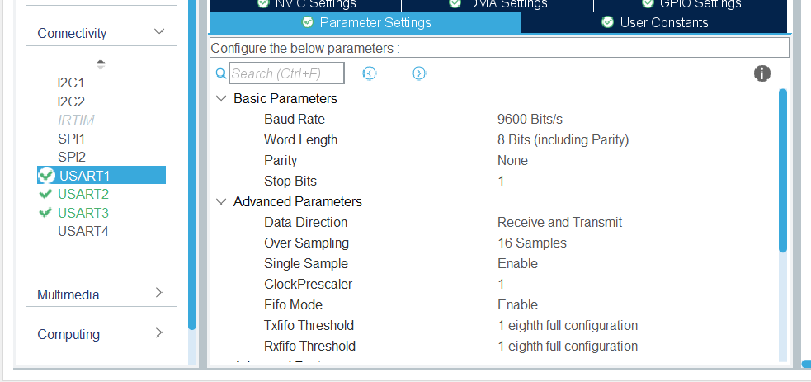

**UART SETTINGS (for meter1):**

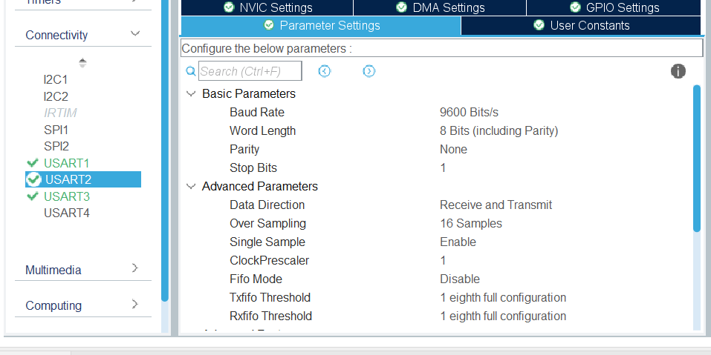

**UART SETTINGS (for meter2):**

